LAPORAN PRAKTIKUM

PEMROGRAMAN 1

Nama : Mochammad Fahrudin

Npm : 4513210024

1. Nilai ascending

//Program 01A

public class nilaiascen{

public static void main (String[] args){

for(int line =1; line <= 9; line++){

for(int j=1; j <= line; j++){

System.out.print(line);

}

System.out.println("");

}

}

}

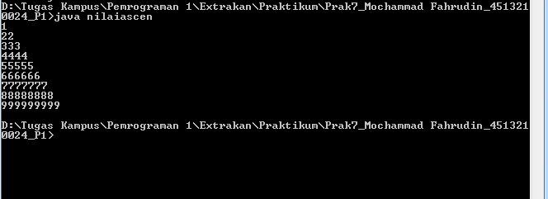

1. Nilai descending

//Program 01B

public class nilaidescen{

public static void main (String[] args){

for(int line =9 ; line >= 1; line--){

for(int j=1; j <= line; j++){

System.out.print(line);

}

System.out.println("");

}

}

}

